PROCESS INSTALL
- Download program in any work folder
- For registered use program enter email address that was used for payment (in left side panel)
- Get temporary security key for work program/server in Full-featured mode (in left side panel)
- Enter this key in field on panel in left side
- Start server

DESCRIPTION PAGE/PANELS PROGRAM
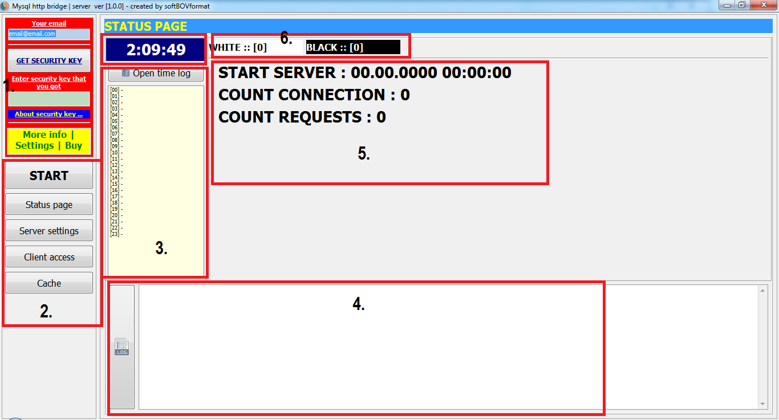
Image N1. Status page.
- Panel for registered use
- Panel for function buttons
- Panel for show time log
- Panel for show main log
- Status data for worked server
- Status data for tables clients
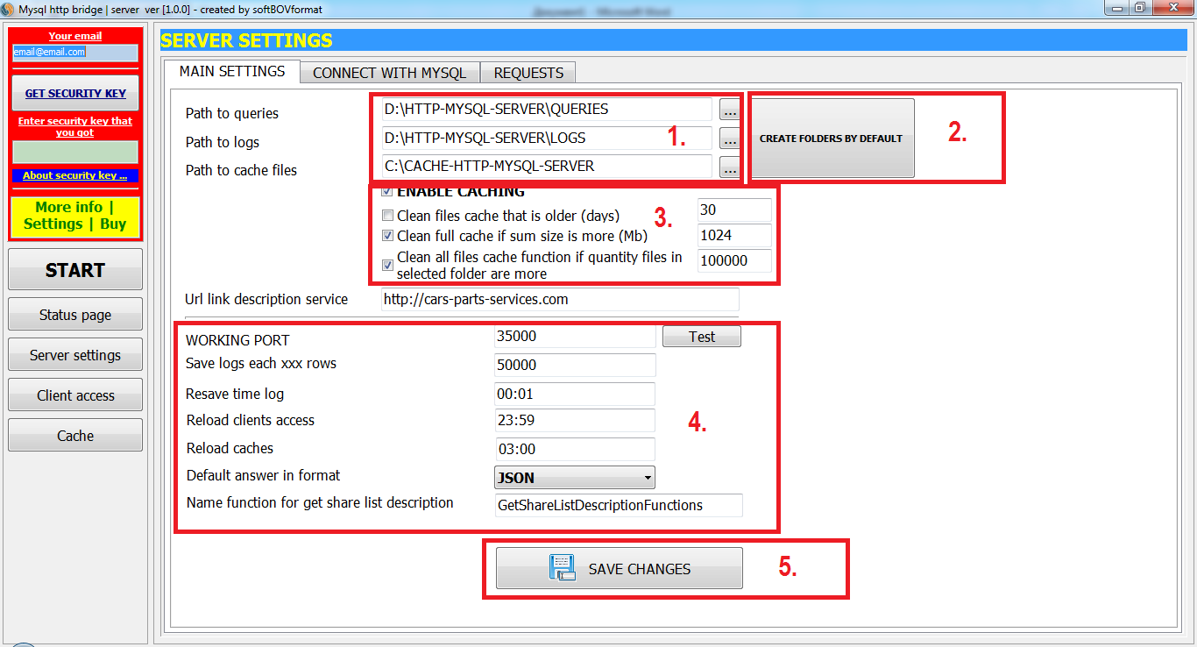
Image N2. Server settings page. Main settings page.
- Panel settings paths to place work folders with queries, logs, cache data
- Button for create work folders with by default paths
- Settings for cache functions
- Panel for main settings
- Button for save did changes

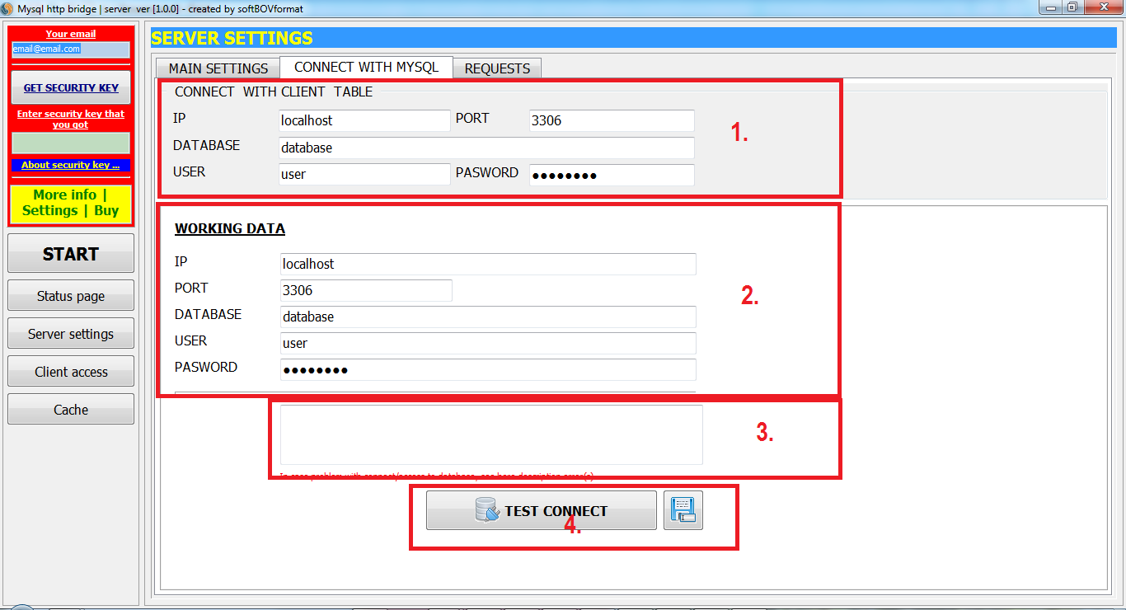
Image N3. Server settings page. Connect with Mysql.
- Panel settings to access to client data
- Panel settings to access to work data
- Panel show errors in case wrong connect with database(s)
- Buttons for save changes and test connect with databases

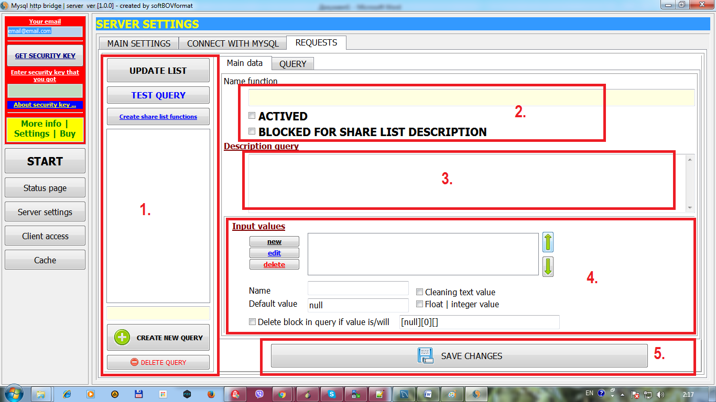
Image N4. Server settings page. Requests. Main data.
- Panel show existing functions and buttons for create/delete functions. Button for locale test function (with input parameters by default according settings function). Button create/resave fale with description functions
- Panel settings activity values for selected function
- Description function
- Panel settings for input values
- Save did changes

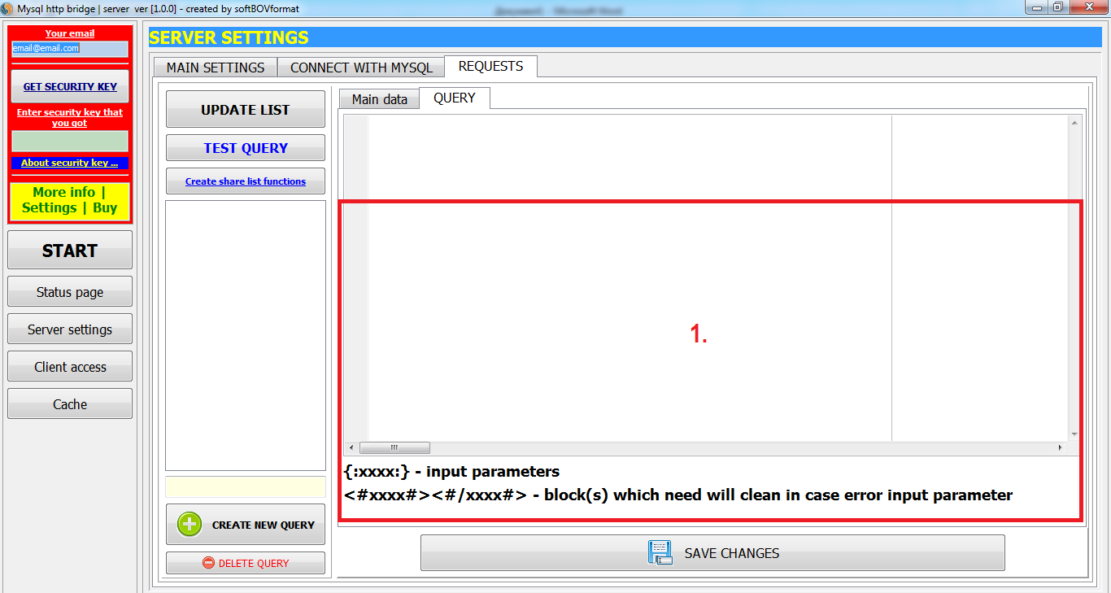
Image N5. Server settings page. Requests. Query.
- Panel show/edit query

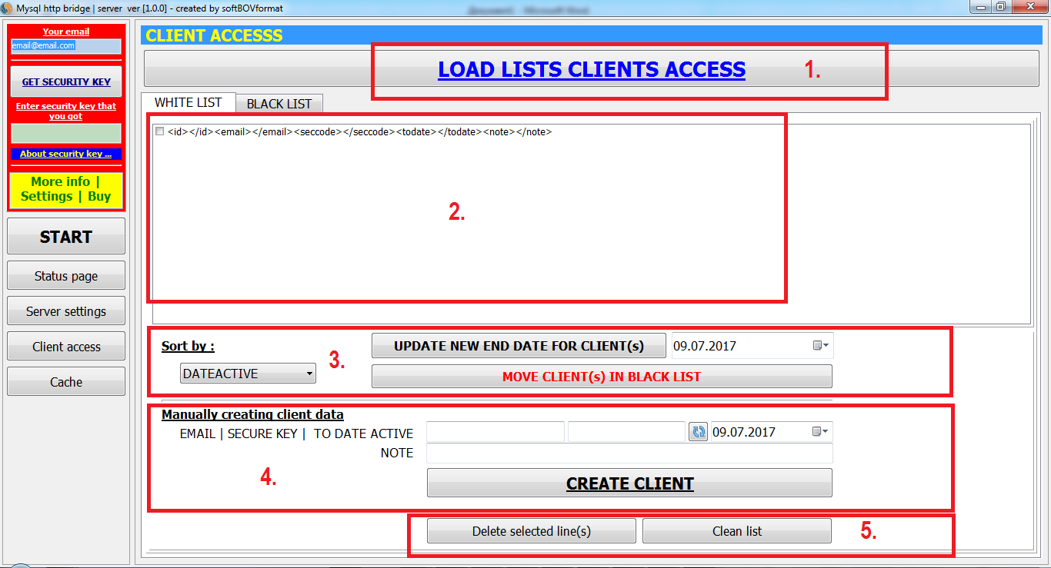
Image N6. Client access page. White list.
- Button for load client tables
- List clients that are registered for use service
- Sort show table. Update activity clients
- Manually create client
- Buttons for delete client(s)

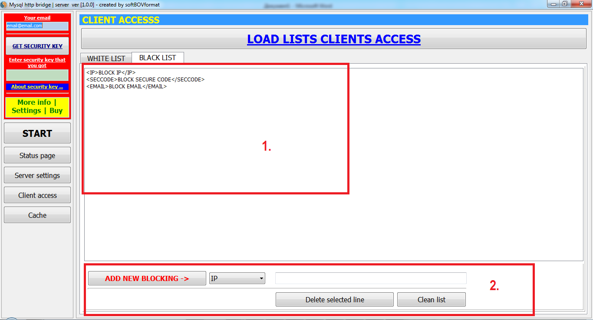
Image N7. Client access page. Black list.
- List blocked data
- Panel for create new blocking

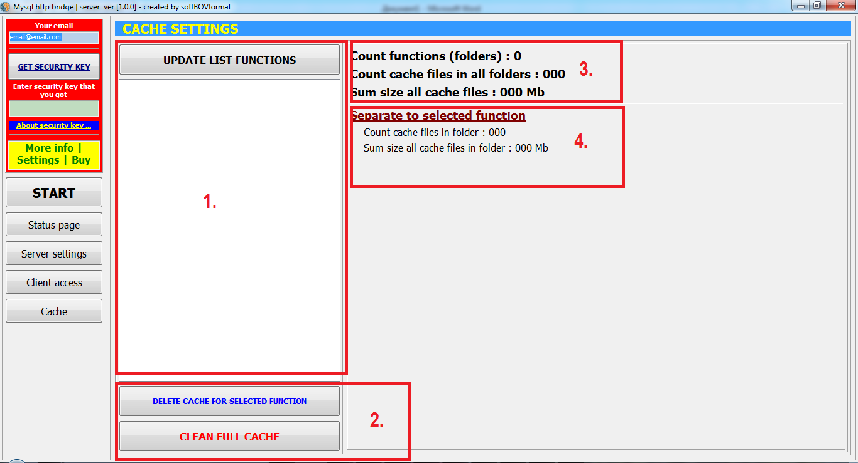
Image N8. Cache settings page.
- List functions that use cache
- Buttons for edit cache data
- Status data to common cache
- Status data to selected function

