PROCESS INSTALL
- Download program in any work folder
- For possibility work with full version need have registration to WebService http://cars-parts-services.com/services-api-integration/57-web-service-rest-api-mysql-to-jsonxmlcsvtxt.html
- In case work without registration program will reconnect for work with demo server, where will only data for AUDI, BMW, MERCEDES-BENZ and brands of products ATE and FEBI BILSTEIN
- For possibility show prices from own price lists need do settings for panel “CONNECT TO YOUR PRICE LISTS”
- For possibility do export and analyze for prices need have registration for services : “COMPARE PRICES” and “ANALIZATION OF PRICES” http://cars-parts-services.com/services-api-integration/37-service-to-comparison-prices-for-different-shops.html

DESCRIPTION PAGE/PANELS PROGRAM
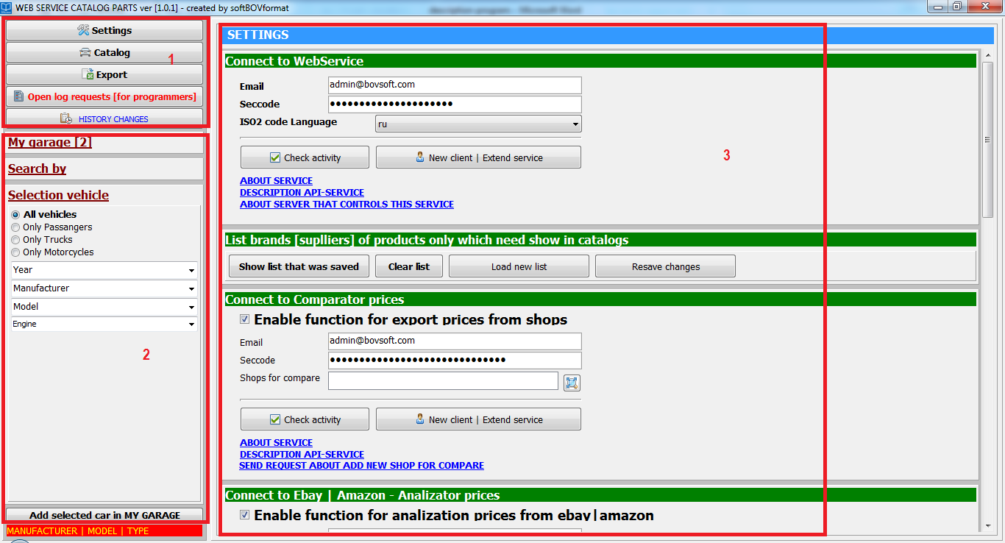
- Functional buttons :
- open page settings
- open page catalog
- open page export data

- Panels for :
- page my garage
- Search by : K-TYPE, KBA, MIME, NAME PRODUCT, CROSS-REFERENCE
- selection vehicle

- Page settings :
- registration with web service
- registration with service compare prices
- registration with service analization prices
- show only necessary brands
- show prices own price lists
- open necessary search url pages
.

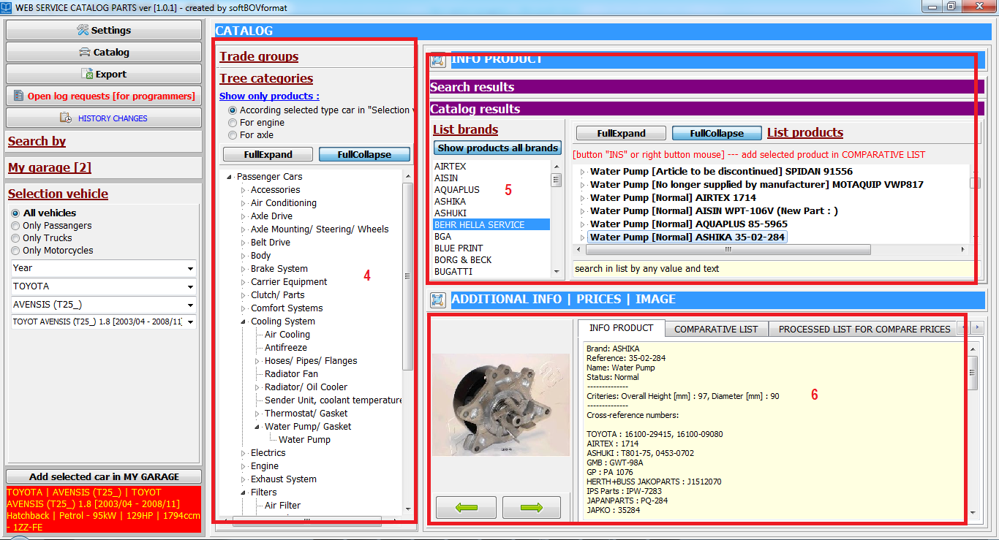

- Panel show tree categories and trade groups for selected vehicle

- Panels :
- search panel. Show brands for search article number
- panel results after choose necessary data in tree categories/trade groups or after search necessary article number

- Page info product. Pages for compare and analyze article number

